**Moving Input Data to HDFS**

Creating InputData folder in HDFS

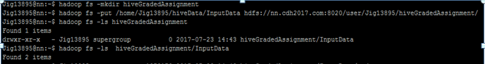

Moved the input files into corresponding sub directories in the InputData folder

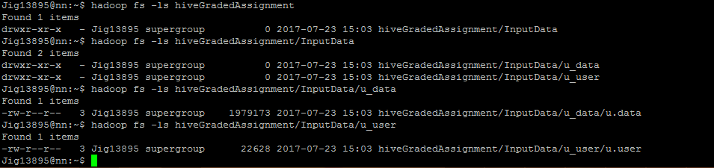

New database is created with the name of cts_Jig13895

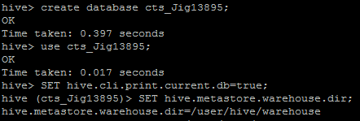

Thus we can see the directory for the above database in warehouse

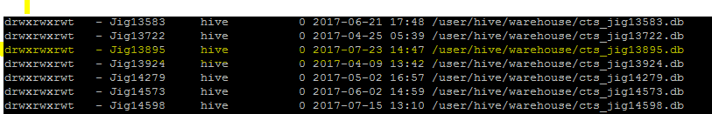

Initially there are no files under the created directory by hive.



**1. Create an external table u_data for u.data in HDFS.**

CREATE EXTERNAL TABLE IF NOT EXISTS u_data(userId INT,itemId INT,rating INT,timestamp STRING)

ROW FORMAT DELIMITED

FIELDS TERMINATED BY '\t'

LINES TERMINATED BY '\n'

LOCATION 'hdfs://nn.cdh2017.com:8020/user/Jig13895/hiveGradedAssignment/InputData/u_data';

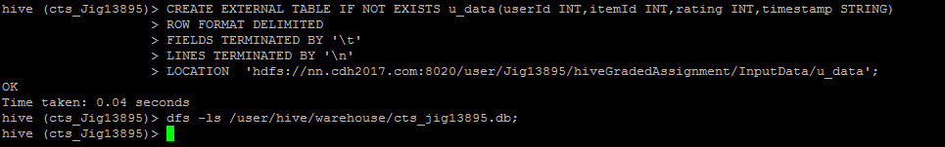

Since we created external tables, the files in HDFS are not moved under the created database. HDFS has full control of the data.



**2. See the field descriptions of u_data table**

describe u_data;

describe extended u_data;

The description shows it is an external table.

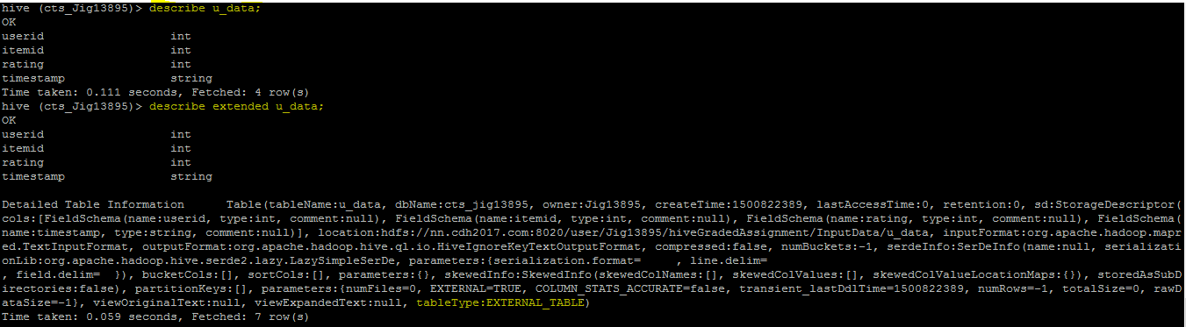

describe formatted u_data;

The description shows it is an external table as well as it lists the input and output format.

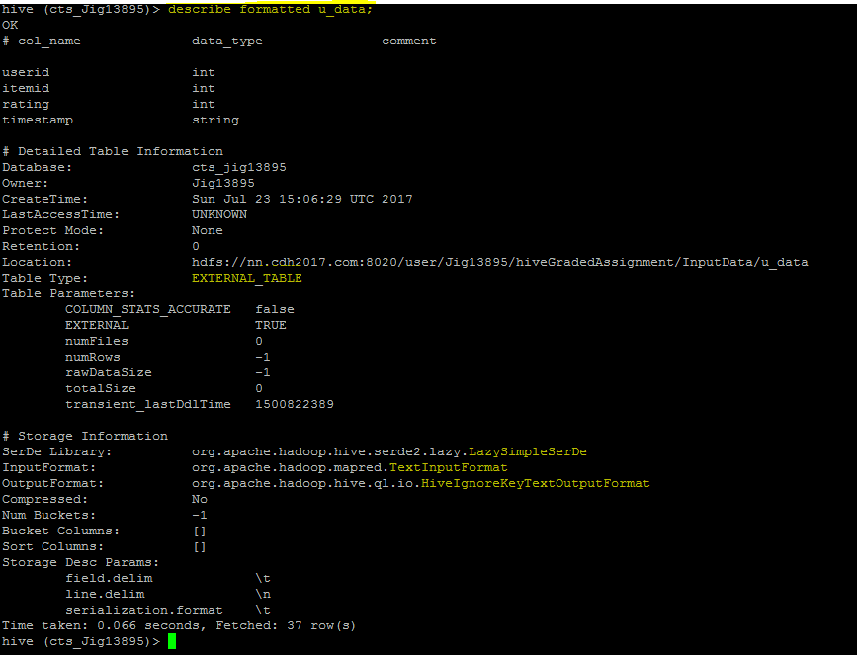

**3. Show all the data in the newly created u_data table**

select * from u_data;

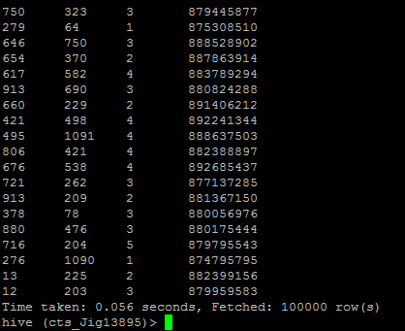

select * from u_data limit 10;

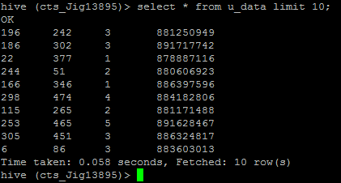

**4. Show the numbers of item reviewed by each user in the newly created u_data table**

SELECT itemId,count(*) FROM u_data GROUP BY itemId ORDER BY itemId ASC;

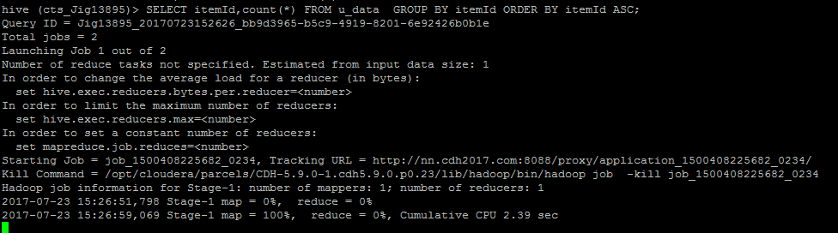

Limit to 10 items

SELECT itemId,count(*) FROM u_data GROUP BY itemId ORDER BY itemId ASC limit 10;

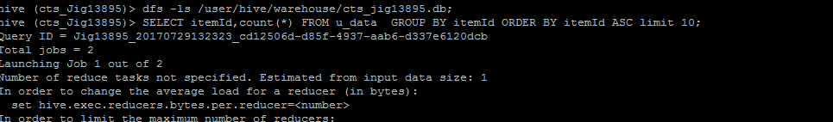

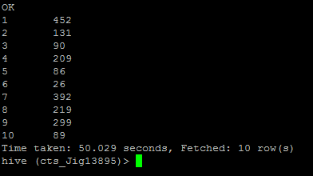

**5. Show the numbers of users reviewed each item in the newly created u_data table**

SELECT userId,count(*) FROM u_data GROUP BY userId ORDER BY userId ASC;

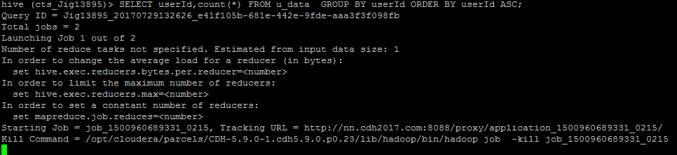

Limit to 10 items

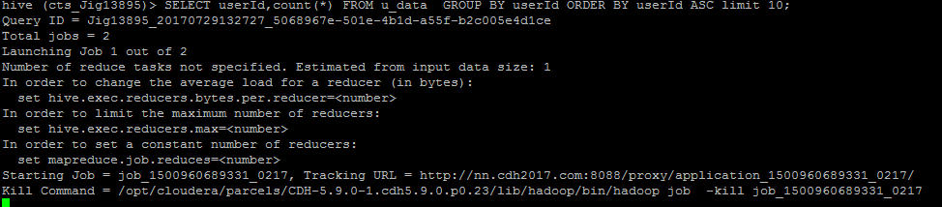

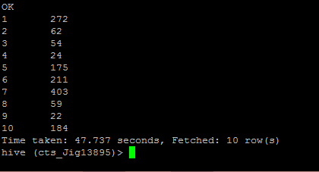

**6. Create an external table u_user for u.user in HDFS .**

CREATE EXTERNAL TABLE IF NOT EXISTS u_user(userId INT,age INT,gender STRING,occupation STRING,zip STRING)

ROW FORMAT DELIMITED

FIELDS TERMINATED BY '|'

LINES TERMINATED BY '\n'

LOCATION 'hdfs://nn.cdh2017.com:8020/user/Jig13895/hiveGradedAssignment/InputData/u_user';

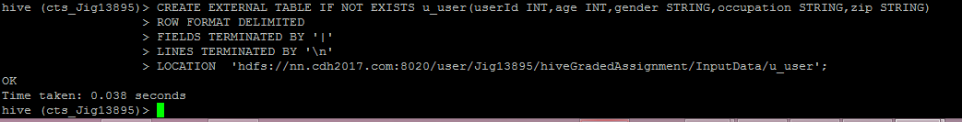

**7. See the field descriptions of u_user table**

describe u_user;

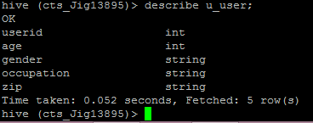

describe extended u_user;

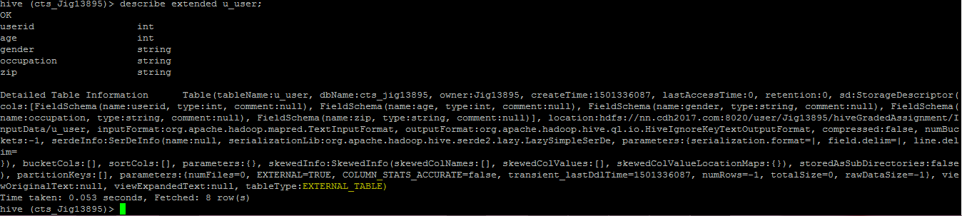

describe formatted u_user;

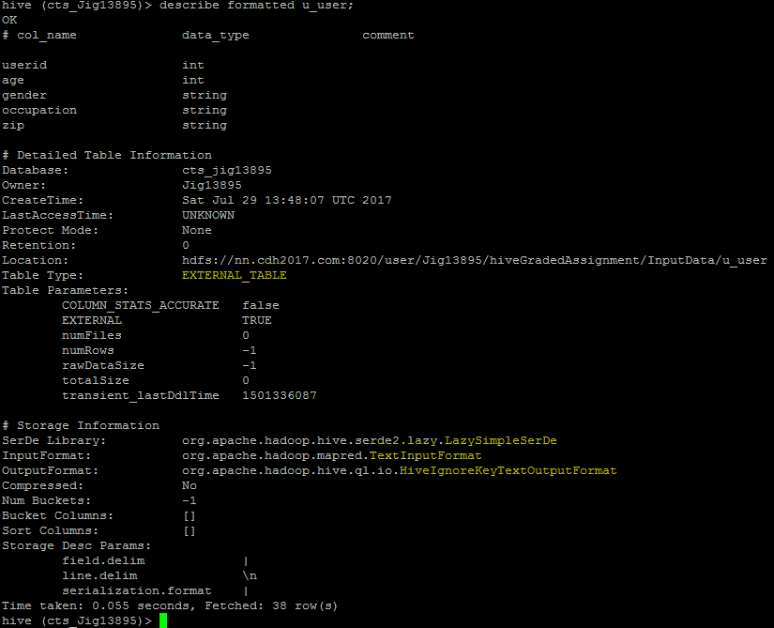

**8. Show all the data in the newly created user table**

Select * from u_user;

Select * from u_user limit 10;

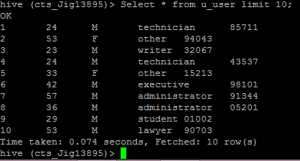

**9. Count the number of data in the u_user table**

select count(*) from u_user;

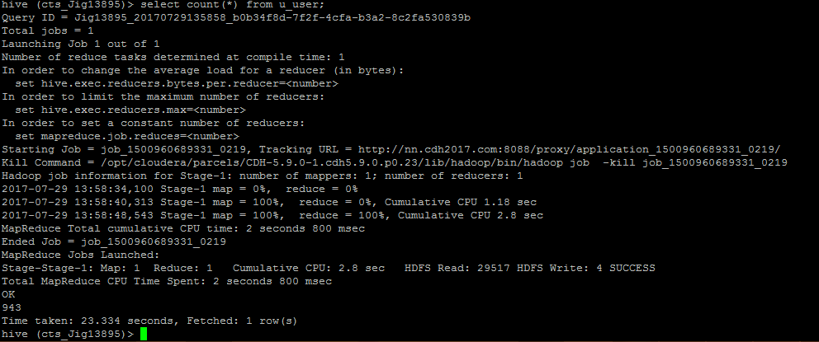

Output is **943**

**10. Count the number of user in the u_user table genderwise**

SELECT gender,count(*) FROM u_user GROUP BY gender;

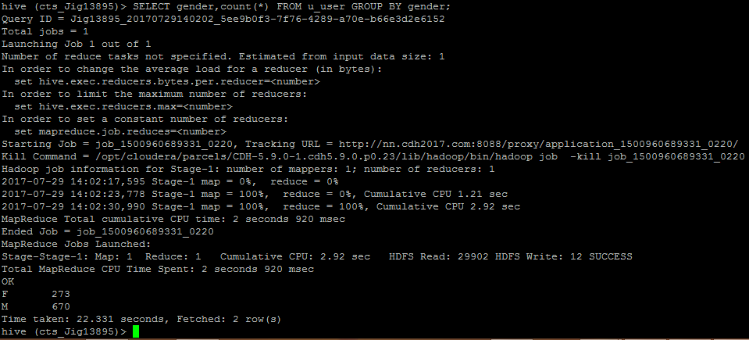Output: **male -273; Female-670 ;**

**11. Join u_data table and u_user tables based on userid - Perform a reduce side join and map side join for the same and compare the time taken in both cases.**

**Map Side Join:**

SELECT /*+MAPJOIN(u_user) */ u_data.userId,u_user.gender

FROM u_data

JOIN u_user on u_data.userId=u_user.userId limit 10;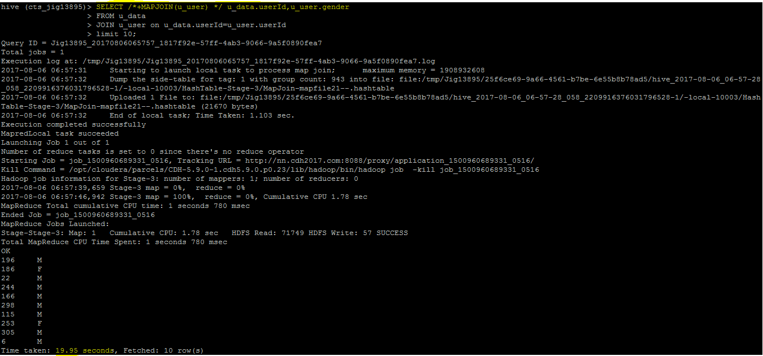

**Total seconds:19.95 seconds**

**Reduce Side Join:**

SELECT u_data.userId,u_user.gender

FROM u_data

JOIN u_user on u_data.userId=u_user.userId limit 10;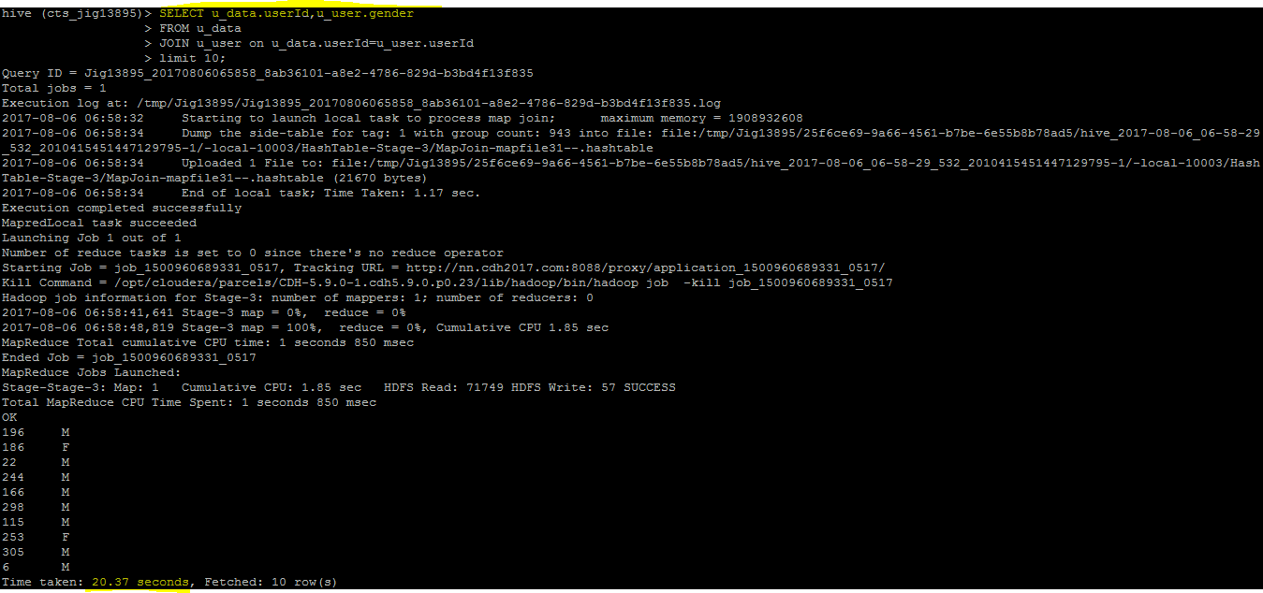

**Total time:20.37 seconds**

**Comparision of map side and reduce side join from the results**

🡪The map side join take less time to complete than the reduce side join

🡪So it can reduce the cost incurred at the shuffle stage and the reduce stage

**12. Create a partitioned table u_user_partitioned, partitioned by occupation column**

CREATE EXTERNAL TABLE IF NOT EXISTS u_user_partitioned(userId INT,age INT,gender STRING,zip STRING)

PARTITIONED BY (occupation STRING)

ROW FORMAT DELIMITED

FIELDS TERMINATED BY '|'

LINES TERMINATED BY '\n';

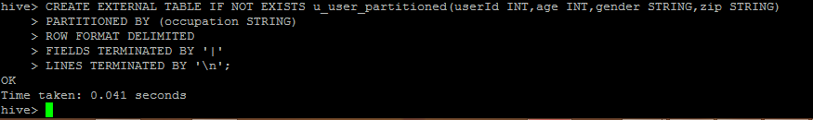

The table u_user_partitioned by the occupation column

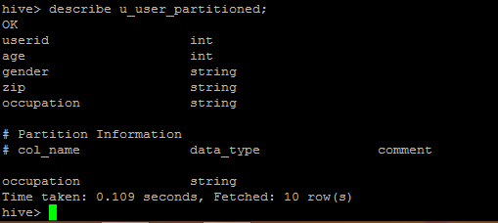

To enable dynamic partition ,the dynamic partition mode parameter should be set to non strict



Insert the data into partition table from u_user table

INSERT OVERWRITE TABLE u_user_partitioned

PARTITION(occupation)

SELECT userId,age,gender,zip,occupation

FROM u_user;

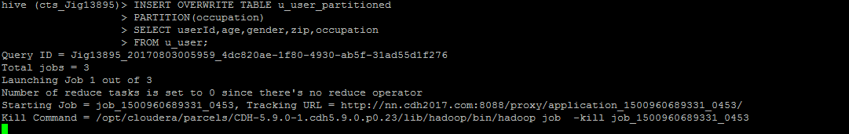

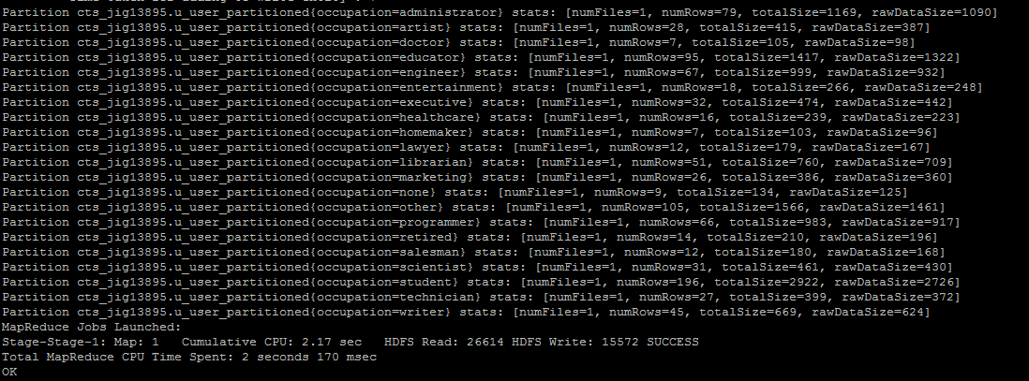

**13. Find out the total number of male and total number of female only for the most common occupation – you can hard code the occupation/ use subqueries. - Perform the query on both un-partitioned table and partitioned table. - Compare and report the performance differences.**

Select the distinct occupations

SELECT occupation FROM u_user GROUP BY occupation;

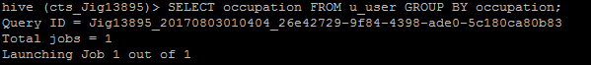

The distinct occupations are

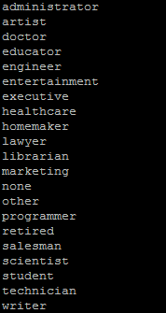

The total number of male and total number of female for the occupation **student** from **u_user** table

SELECT gender,count(*) FROM u_user where occupation="student" GROUP BY gender;

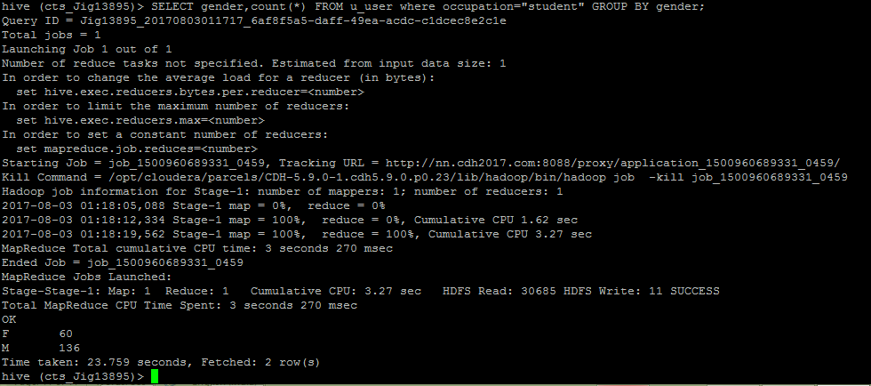

Total male=**136** ; Total female=**60**

Total:**196**

Time taken:**23.7 seconds**

The total number of male and total number of female for the occupation **student** from **u_user_partitioned** table

SELECT gender,count(*) FROM u_user_partitioned where occupation="student" GROUP BY gender;

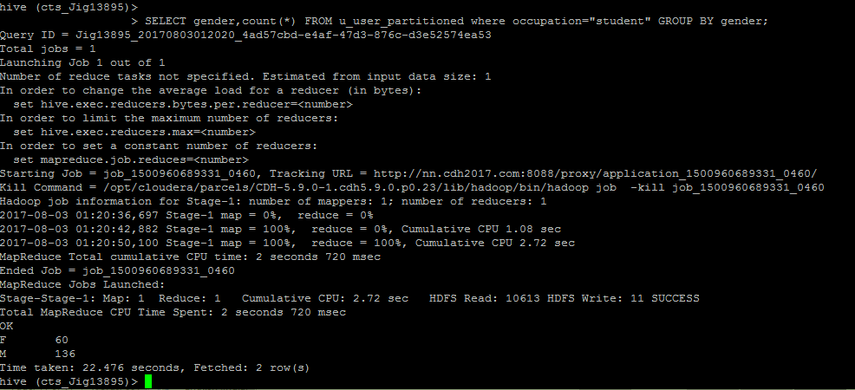

Total male=**136** ; Total female=**60**

Total:**196**

Time taken:**22.47 seconds**

Comparison of u_user and u_user_partitioned tables from the results

🡪The time taken for the user_partitioned table is comparatively less than the u_user table

🡪The number of reads from HDFS is reduced in case of a select from u_user_partitioned table

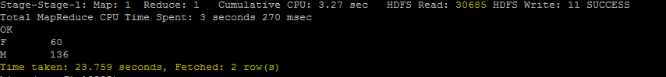

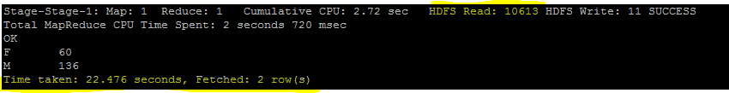

🡪In case of partitioned tables the reduced stage takes less time

**Using case statement:**

select count(*) as total, sum( case when gender = 'M' then 1 else 0 end ) as male

, sum( case when gender = 'F' then 1 else 0 end ) as female

from u_user where occupation = "student";

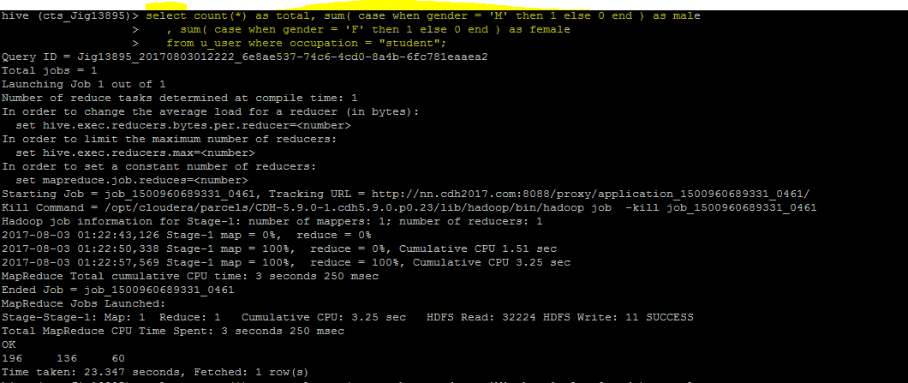

Time taken:23.3 seconds

select count(*) as total, sum( case when gender = 'M' then 1 else 0 end ) as male

, sum( case when gender = 'F' then 1 else 0 end ) as female

from u_user_partitioned where occupation = "student";s

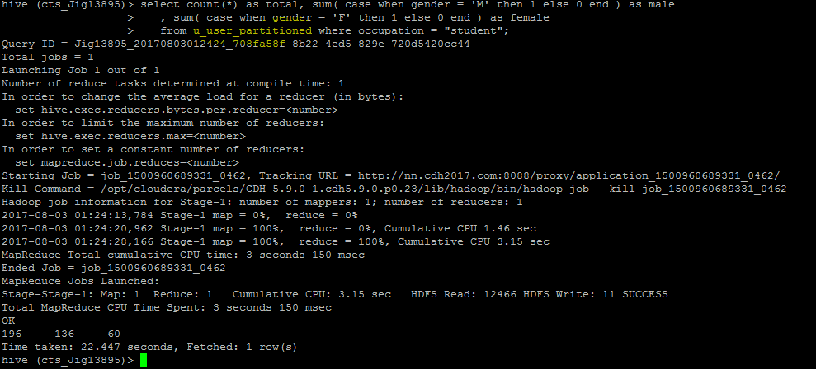

Time taken:22.44 seconds